User Acceptance Testing (UAT) — ServiceNow Employee Import
Date | 30 September 2026
Team ID | SN-TRANSFORM-01
Project Name | Import Data using Transform Maps (Spreadsheet)
Maximum Marks | 4 Marks

Project Overview:
Project Name: Import Data using Transform Maps (Spreadsheet)
Project Description: Validate spreadsheet intake, Transform Map behavior, Employee ID coalescing, validation and reporting in ServiceNow.
Project Version: Phase-II baseline / UAT-1
Testing Period: 30 September 2026 to 09 October 2026
Testing Scope:
Employee Import staging; Employee Test target table; five field mappings; Transform History; insert/update behavior; department, location and employee-list reports; Employee Analytics Dashboard.
User Stories: USN-1 through USN-8 from the approved Phase-II backlog.
Testing Environment:
URL/Location: ServiceNow instance — Employee Import, Transform Maps, Employee Test and Reports modules
Credentials (if required): Use the assigned ServiceNow administrator and data-owner roles; do not record passwords in this document.
Test Cases:
Test Case ID | Test Scenario | Test Steps | Expected Result | Actual Result | Pass/Fail
UAT-001 | Load valid employee spreadsheet | Upload Sample Spreadsheet.xlsx; inspect staging rows and headers. | Employee Import contains expected headers and row count. | Pass | Pass
UAT-002 | Transform valid rows | Run Sample Spreadsheet Import Transform Map. | Five mapped fields populate Employee Test without errors. | Pass | Pass
UAT-003 | Repeat import / coalesce | Change one employee row and add one new Employee ID; rerun transform. | Existing ID updates; new ID inserts; no duplicate is created. | Pass | Pass
UAT-004 | Validation and history | Review Transform History and target records. | Inserted, updated, ignored and error outcomes are visible and traceable. | Pass | Pass
UAT-005 | Reports | Open department, location and employee-list reports. | Reports show the transformed Employee Test records with correct filters. | Pass | Pass
UAT-006 | Dashboard | Open Employee Analytics Dashboard. | Dashboard presents current import outcomes and employee summaries. | Pass | Pass

Bug Tracking:
Bug ID | Bug Description | Steps to reproduce | Severity | Status | Additional feedback
BG-001 | No defect observed in documented baseline | Review acceptance criteria and configuration evidence. | None | Closed | No defect observed; keep execution evidence with the test record.
BG-002 | No additional defect identified | No reproduction steps required. | None | Closed | Reserved for any later live-instance finding.

Sign-off:
Tester Name: To be assigned
Date: To be completed after UAT execution
Signature: To be completed by tester / product owner
Notes:
- Execution note: cover positive and negative cases, record detailed feedback, classify defects by severity and status, and obtain product-owner sign-off before deployment.

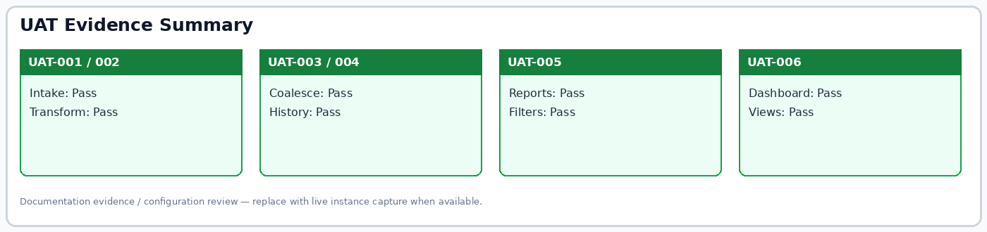
Figure: UAT evidence summary; statuses reflect documented project evidence review.

